University of Colorado
Plastic and Reconstructive Surgery
Acting Internship (AI) Rotation

General Information
Course Coordinator: Kathleen Tuthill (Interim)
E-mail: kathleen.tuthill@cuanschutz.edu
Cell: 917-855-4239

Course Director: Dr. David Mathes
E-mail: david.mathes@cuanschutz.edu

Welcome to the University of Colorado Plastic and Reconstructive Surgery elective – We’re all excited to have you! Your time with us should be about learning plastic surgery while also getting to know our program, residents, attendings, and Denver. While you’re with us, you will rotate at 3 of our 4 different hospitals – Denver Health (“DG”/”DH”), UCHealth (“University”), Children’s Hospital of Colorado (CHCO). The sites provide a depth and strength to the program, and you will see a variety of patient populations and cases. University is on the main Anschutz campus, along with CHCO and the VA, which are all located in Aurora. Denver Health, our community hospital, is located in downtown Denver.

Leadership
Chief: Dr. David Mathes
Program Director: Dr. Mark Greyson
Associate Program Director(s): Dr. Corrine Wong, Dr. Julian Winocour

Interviews
You will be interviewing at the end of your rotation! Our program coordinator will send you calendar invites the last week of your rotation with different pairs of attendings. At this point, they are over zoom and occur over multiple days in the mornings based on surgeon availability. These may eventually switch to in-person, so I’d recommend bringing interview clothes just in case (or confirm with coordinator before you come to save luggage space).

Core topics to cover during your rotation
- General: wound healing, infections, flaps and grafts
- Peds: cleft lip/palate, craniosynostosis, vascular malformations/skin lesions, congenital hand
- Hand: fractures, nerve compressions, tendons, infections
- Breast: augmentation, reduction, recon (implant and autologous)
- Trunk/Lower Extremity: trunk recon, pressure sores, lower extremity recon
- Head/Neck: facial trauma
- Aesthetic: body contouring, facial aesthetic procedures

Rotations (1 week each)
Our program coordinator will email you your specific weekly schedule so that you are ideally the only sub-I on a service at one time. If there is a light day, you are welcome (and encouraged) to go to different services/hospitals to join in on surgeries going on. Just speak to your chief to help facilitate this.
- Denver Health
- Children’s
- University Hand/Extremity
- University Plastics

Where to Stay
- In the past, people have used Rotating Room, Facebook, Air BnB/VRBO, etc. Air BnB has long term rentals (30 days) that can be pretty affordable.
- Three of your four weeks will be spent at the Anschutz campus, so it makes the most sense to live in Aurora, Lowry or Stapleton/Central Park (~5-10 minute drives). These will be the closest to the hospital and typically the cheapest options.
- If you want to stay in Denver, the best neighborhood to look in is City Park (~10-20 minute drive) or Congress Park. If you stay deeper in the Denver area (Downtown, Baker, RiNo, Highlands), the drive is typically between 20-40 minutes depending on traffic. These options may also be more expensive.

Transportation
We highly recommend renting a car (or bringing your own!) so that you are flexible, safe, and able to fully focus on crushing your rotation. Although we understand that it is definitely more expensive, it will guarantee you arrive on time to your rotations and also offer you the ability to explore Denver in your free time or even go out to the mountains, as well as to get to/from the different hospitals without having to walk in the dark. You will also be taking home call, which requires you to drive between hospitals from home. We do not recommend relying on public transportation for this rotation.

Some students have opted to not have a car in the past and chose to use Ubers or walk if close enough to the hospital. This is doable, but again not recommended. Ubers are not always reliable, especially in the earlier hours, and also may not be very cheap depending on when you’re requesting them. Some students have also bought bikes (used or new) and gotten to/from the hospital that way. However, you’ll ultimately need some form of transportation to get to/from Denver Health, which is 20-30 minutes away from Anschutz.

The Wiki
The Wiki page is our bible and you are HIGHLY encouraged to use it. It contains our call schedules, attending operative reports and preferences, postoperative pathways for our inpatients, important phone numbers, etc. If you have a question, the answer is usually on the Wiki.
Pro move: reading through the operative reports will be a quick way to check the relevant anatomy, where incisions will be made, etc. when preparing for a case.

Website: http://ucresident.com
Username: subi
Password: subi

Conferences
- Didactics: every Monday 6-8 or 7-8 depending on the week, in person (or Zoom if at Denver Health).
  - Attending lectures (ask your team for the conference schedule ahead of time so you can prepare)
  - Study with the Chiefs: study session led by our chief residents
- Hand Conference: every Wednesday 5-6pm on Zoom
  - Lectures given by Plastic Surgery and Ortho Hand attendings
- Mathes Conference: once a month on Wednesday at 6:30am
  - Each resident submits a log of cases and Dr. Mathes asks questions, typically directly from Janis, and provides donuts!
  - Refer to the Wiki to see when on your specific rotation the conference is scheduled
- M&M: once a month on Zoom, typically the first week of the month
  - Residents present complications from the previous month

On Sunday of every week, the chief of University service will send out a schedule including what exact conferences are happening and when/where.

Call Schedule
You will be expected to take one weekday call shift per week and two weekend days (Saturday OR Sunday) per month. These call shifts should be on days when we are covering Children’s Face, University Face and/or University Hand (should not be a normal Plastics only call day). Refer to the Wiki (example below) to see which days we are on call. We cover all four hospitals when on call, so you may have to drive between sites.
CF: CHCO Face
UF: University Face
UH: University Hand

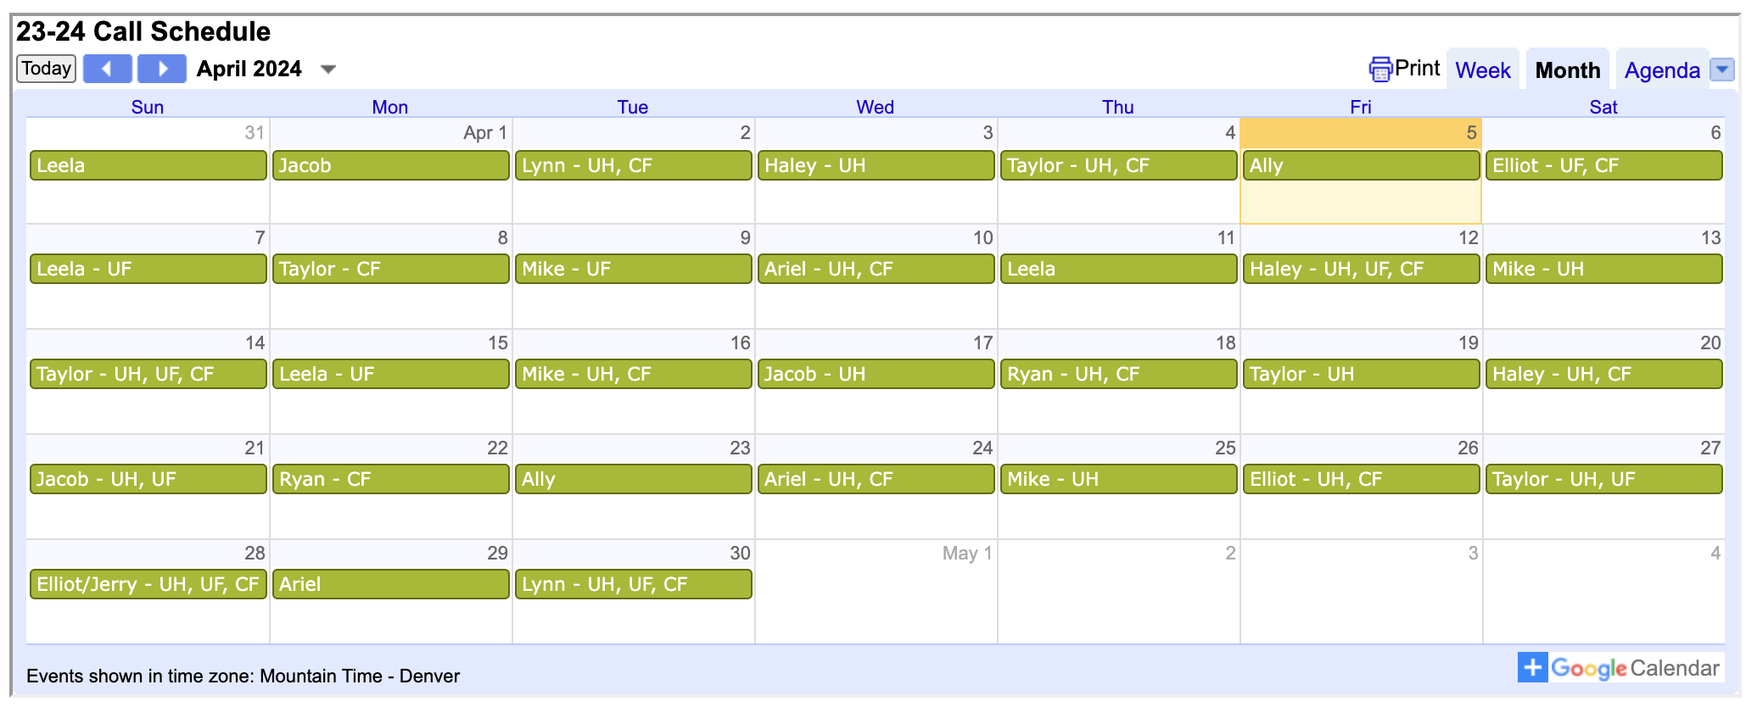

Coordinate amongst the other AI students to see who will take what day and then let someone from your team know or text that specific resident. We will then send the info to our group chat so that everyone knows.

These call shifts are “home calls,” meaning you can stay at home and wait until there is a consult. There are beds in the call room you can sleep in, as well, if needed.

Weekday calls start at 6pm (12 hours). Text the on-call resident earlier that day to say that you will be on call with them and check in with them at 6pm to see if there are any cases that need coverage or consults that need to be seen. Before you go home, you can also ask the resident you’re working with to see if there are any cases going late that you can go help with.

Weekend calls start at 6am (24 hours). Text the on-call resident the day before to say that you will be on call with them and check in with them at 6am. They will call you when there are consults or cases.

Post-call days: If you were on call overnight and it was very busy, you can take a post-call day. Usually this means you leave by noon but can be individually tailored based on what is going on that day. You should discuss it with your chief and mid-level. If there are cases you’re interested in seeing and want to stay, that is entirely up to you but is not an expectation!

How to Prepare
- For cases: know generally how the surgery is done, watch videos, know the relevant anatomy/disease process, know your patients
  - You can look up some operative reports on our Wiki website (see below)
- For rounds: bring dressing supplies (sometimes requires some anticipation, but you can also ask your team the day before if you aren’t sure), know the patients
- Before you start at your specific site, ask the residents to add you to the shared Plastics patient lists. This can be done by your resident, intern, or the medical student who came before you.

Making a List
Vitals: T max / HR range / BP range / RR single value / Desaturation events and times + Oxygen/Vent settings (please do not write “VSS”)
Ins and Outs: Total/Total
- PO
- IV
- BM, emesis, etc.
- Drains/WV:
  - Separate for each,
  - Document output over 24 hours with previous 24 hours in parentheses: 100(200)
  - Make sure you are opening up all the tabs in Ins&Outs to get all of the drains
Any relevant imaging
Cultures (with dates)

Rounding
Medical students should LEAD rounds. On a heavy dressing change service (University and University Hand), please carry the dressing supply bag (in call room). Due to the flow and speed of rounds, medical students do not typically present patients. We typically run the list before rounds and you can ask to lead this process with the disclaimer that every chief resident is going to be a little different, so just ask them their expectations at the beginning of each rotation.

Pro move: always carry a pair of trauma shears

Weekend Rounding
You should plan to round one day per weekend on each service you are on. If you are taking call one weekend day, you can round that morning so you have at least one day each weekend off. There is a rounding schedule on the Wiki (example below) that tells which resident is rounding on what service so you can coordinate with them. Weekend rounding times vary depending on the resident, so just reach out to them the day before to confirm. Sometimes, if the service you are on has an intern, they will also round on the weekends, so you can coordinate with them so you work opposite days.

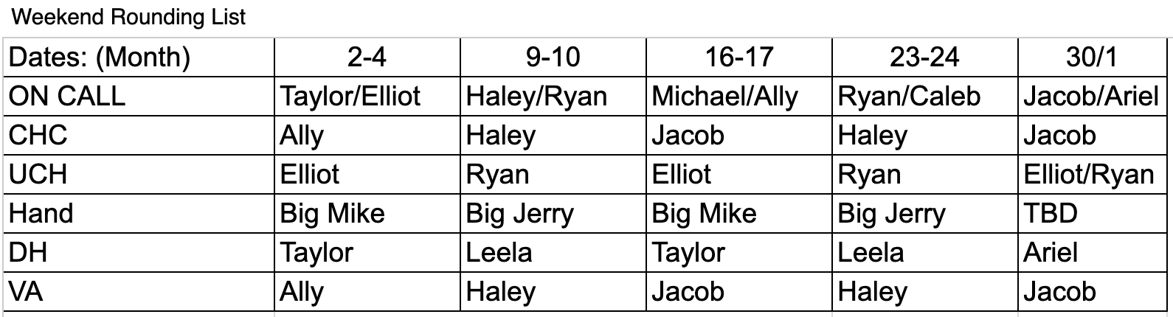

Supplies and “Go Bags”
There are buckets with supplies in the call room at University where you can go shopping for supplies if you need to replenish anything before rounds.

Always carry a “go bag” on call or on rounds. There is a bag for dressing supplies in the call room that you can use or you can BYO (fanny pack/backpack). Having this bag makes rounding and consults run more efficiently and is always GREATLY appreciated.
Things to pack: Lidocaine, 18 gauge needle, 22-25 gauge needles, 10cc syringe, kerlix, gauze, prep sticks, betadine, bacitracin, iodoform packing strips, 10 blade, 15 blade, ABD pads, Adaptic, Xeroform, lube, silk tape, fabric tape, Medipore tape

*You can tailor this based on the anticipated dressing changes. Always feel free to ask your team the day before what supplies they think will be needed.

Cases
In the OR, here are all the tasks you should help with:
Introduce yourself, write your name and residents name on the board. Write your gloves size too. Get your gloves and hand them to the circulator or ask if they’re okay with you opening them directly onto the field. Help transfer patient from the stretcher to the OR bed. Get the safety strap/belt on the patient. Put the SCDs on the patient’s legs. Be an extra pair of hands to anesthesia to help intubate or put in new IVs. At the end of the case, remove the drapes and put in garbage, help extubate, take off bovie pads, get the stretcher and transfer patient back to stretcher. Please walk the patient to PACU by opening doors. It is also super helpful if you go to the OR early and tell the team when the patient has rolled into the room.

Journal Clubs
We typically have one sponsored journal club per month. Ask the residents on service if there is one scheduled when your rotation starts. Dr. Greyson will send out papers the week before or the week of. Each student is expected to pick and present one article at the journal club (a resident will text you the list and you’ll decide with the other students). You will be matched with a resident and are encouraged to ask them questions and/or discuss the paper prior to your presentation.

The presentation consists of talking (no PowerPoint slides) about the article (breaking down the background, methods, results, discussion (strengths/weaknesses, will this change your practice, etc.). Most students either print out the paper with notes or you can bring laptop/iPad/read from your phone.

This is a great opportunity to eat good food, get to know the faculty/residents and showcase your presentation skills in an informal setting. We all typically dress in business casual for these (bring a change of clothes to hospital because you often won’t have time to go home and change).

Site Specific Information
Denver Health (“DG” or “DH”)

Remote Access: https://dhremoteaccess.dhha.org/vpn/index.html

Attendings: Wong, Malliaris
APP’s: Rosa DiPrima

Scrub Color: Green (Pavilion A), light blue (Pavilion L)

Google Maps “Denver Health” will get you to the main entrance.

Parking
- Delaware Garage: technically “not allowed” but those of us who do it have never been ticketed when parking on the top floors. If you get a ticket, it’s ~$20.
  - On Delaware street between 6th and 8th avenue.
- Acoma Garage: technically the employee garage but a 10 minute walk from the hospital. You need a hospital badge to access, so there’s a chance you won’t be able to get in if you try. There is a shuttle but if you’re getting there super early it likely won’t be running.
  - On Acoma street between 6th and 5th Avenue
- On weekends or overnight, you can find street parking for free in the neighborhood around Denver Health on Delaware and Elati, typically. Between 6th and 8th avenue.

Getting Around
- Once you’ve parked, walk toward Pavilion A (the main entrance)
- From Pavilion A entrance, walk straight back towards the security desk where the metal detectors are and turn left. If you’re walking towards Subway, you went the wrong way.
- After you turn left, walk straight back and on your left side right before the elevators you will see an alcove with a door/sign that says “Staff workroom” that you then can badge into. If you don’t have a badge, text the resident to come grab you or just knock until someone opens.
- Our call room is in the back right corner and labeled “Plastic Surgery.” The door code is the room number.
- You can use any of the computers in the main room to make a list or you can use the computer in our call room.

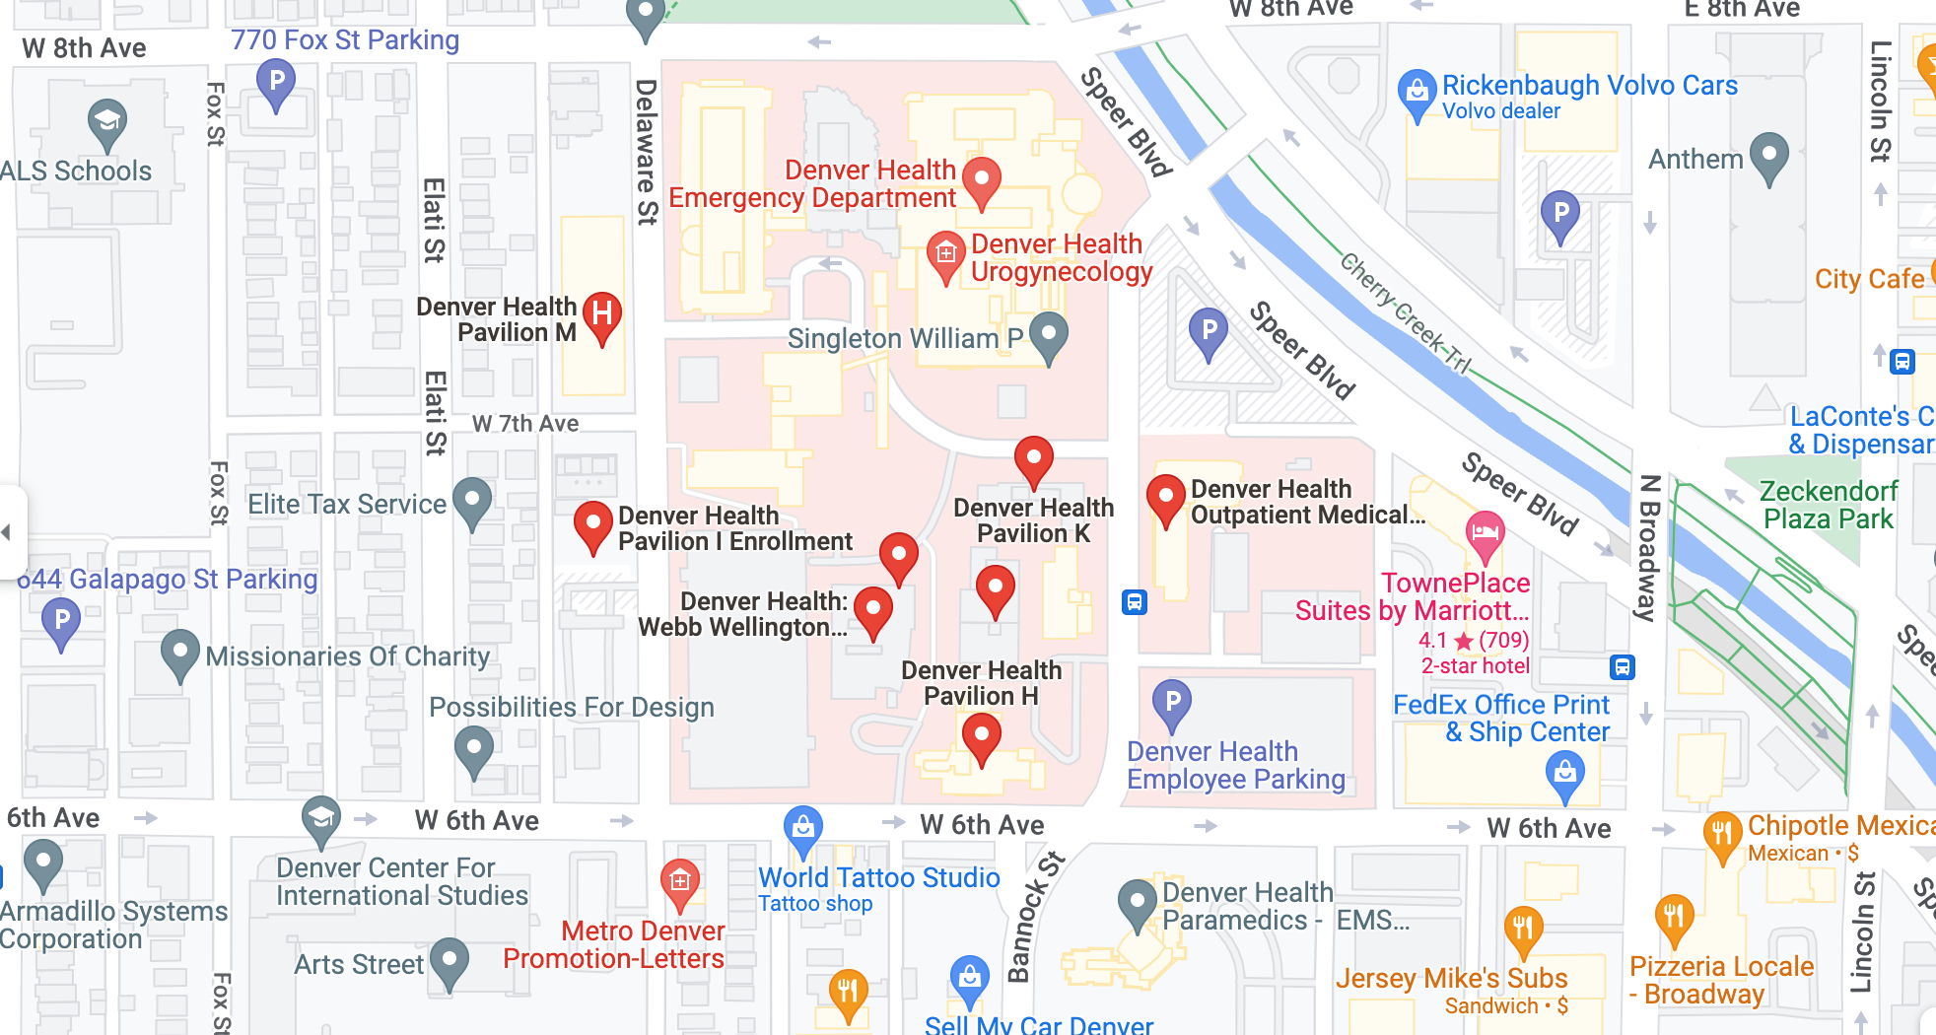

UCHealth (“University”)

Remote Access: https://myapps.uchealth.org/vpn/index.html

Hand/Extremity Attendings: Iorio, Greyson, Washington, Gordon, Irwin
APP’s: Emily Walwood, Ben Nigg, Claire Law

Plastic Surgery Attendings: Mathes, Cohen, Winocour, Kaoutzanis, Yu, Egan. Occasionally, Drs. Khechoyan, Nguyen, and French come over from CHCO to do cases, so add them to your schedules, as well.
APP’s: Nicole Ferreri, Ashley Jacob, Peggy Walsh, Sara Douglass, Marian Brinkman

Scrub Color: Green

Google Maps “UCHealth Employee and Patient Parking Garage” will get you to the main parking garage. Clarify with Program Coordinator where exactly you should park (this has changed multiple times in the past).

Getting Around
Pro Tip: the best way to keep track of where you are is to see your location in relation to the elevators (C, D, E)
- There is a new tower that has been built nearest the ED and parking garage, giving us three total towers. Tower 1 is the oldest and has rooms 1-35. Tower 2 has rooms 55-85. Tower 3 has rooms 100+.
- Door codes: almost every single door in the hospital can be opened with the code 84845.
  - Exception:
    - If you go to the “Canada” storage closet in the ED to get supplies, the code is 5877
    - The code for the smaller storage closet in “Super Track” in the ED is 1976
- The interns sign out on the 11th floor of the third tower (the new one closest to parking garage) at 6am (sometimes earlier), so you will likely meet them there to print and make the list. Take elevator E or elevator in new tower up to the 11th floor and badge into the unit and there is an office at the very end of the hallway. Ask the intern to show you to where to get sign-out on the first day so that you can be there for sign out and hear any overnight events/updates.
- Our call room is on the 2nd floor. Take Elevator D to 2nd floor and walk down hallway in the direction of Elevator C and the Anschutz Outpatient Pavilion. If you see signs to the CT ICU, turn around and go back to the elevators and try again. Along that hallway, before you get to the Outpatient Pavilion, there are a couple rooms. Our call room is in room 2022. The code is 84845.
  - You can store your things here
  - There are two computers in there that you can use to make the list in the morning. There is a printer “PRS” you can use, but no copy machine.
- There are two OR spaces: Central (CEN) and East. They are sometimes referred to as AIP and AOP, respectively, because that was how they used to be named. Both are on the 2nd floor.
  - East is near the Anschutz Outpatient Pavilion across from Elevator C. If you walk down the hallway, the pre-op area will be on the left.
  - Central is between Elevators D and E.
- The ED is on the 1st floor near Elevator E
- Food Options
  - There are two cafeterias on the first floor. There is one right below the outpatient OR’s and one right below the inpatient OR’s.
  - We have a mini fridge and microwave in our call room that you are welcome to use.
  - 17th street has some dining options (Subway, Jimmy John’s, Green House, etc.) but these are ~5-10 minute walking distance.

Children’s Hospital of Colorado (CHCO)
Attendings: Nguyen, French, Khechoyan, Irwin
**This rotation is lighter than others because there are only two attendings. If there is not much going on a certain day, we recommend going to the University to seek out any cases/clinics going.
APP’s: Lindsay Dyer-Kindy, Jordan Paley, Maureen (“Mo”) Andrews

Remote Access: https://go.childrenscolorado.org/Citrix/CHILDRENSSTOREWeb/

Scrub Color: Light blue. You are not allowed to leave the Children’s Hospital wearing the light blue scrubs. Please return these at the end of each day and pick up a new set from outside the locker rooms.

***DO NOT WEAR NAIL POLISH OR LANYARDS! They have nail polish remover wipes available if you forget, but if you have gel nail polish, you will not be able to scrub into the OR***

Getting Around
- We do not have a call room at this hospital.
- The OR’s are on the 2nd floor. There is a physician workroom where the residents typically work next to the OR front desk. It is labeled as “Dictation Room.” You can use these computers and leave your things here during the day. If you print, it goes to the large copy/printer behind the OR front desk.
- Food Options
  - There is a large cafeteria on the first floor. It does take some time to get to and is hard to do in a “quick trip,” so we recommend packing extra snacks/food.

Pro Tip: almost all dressing supplies are in a Pyxis that you have to ask a nurse to open or send up from Central Supply. If you anticipate doing any dressing changes while on rounds, bring a “go bag” with extra supplies or ask the nurses before rounds to have the materials sent up. This is also SUPER helpful when taking call.

Resident Contact Info

https://medschool.cuanschutz.edu/surgery/divisions-centers-affiliates/plastic-and-reconstructive/residency-programs/current-residents

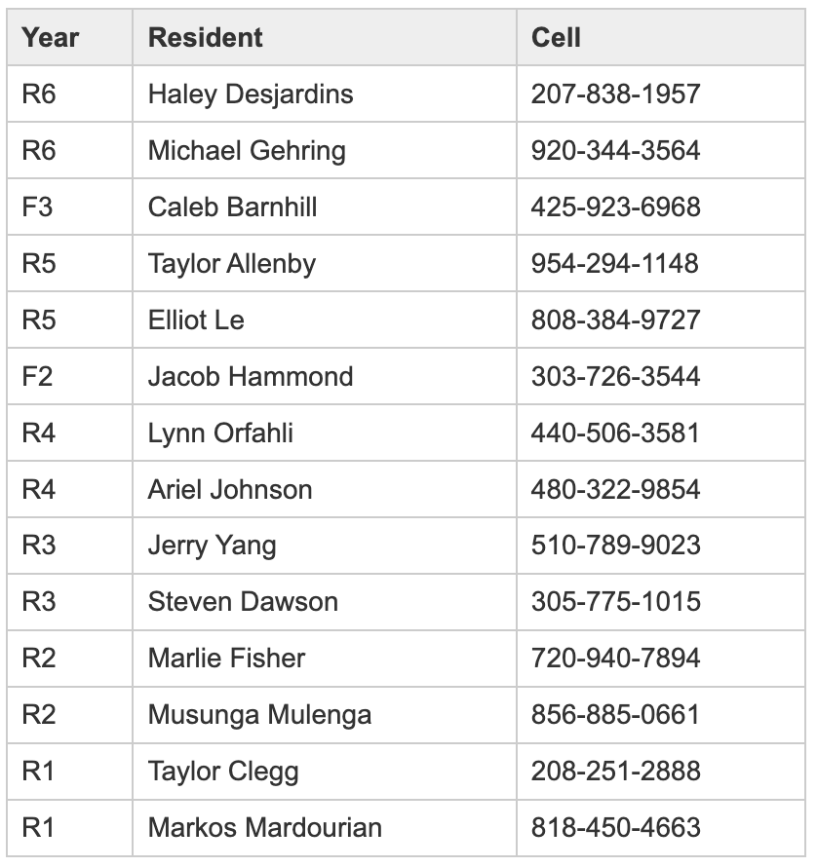

Having Fun in Denver
There are a lot of really great restaurants and breweries in Denver that you should definitely explore while you are here.

Drinking
- If you want to brewery hop, the best place is RiNo in Denver for Ratio, Odell, Our Mutual Friend, Epic, Woods Boss, Improper City, etc.
- Ursula Brewing is on the Anschutz campus and walking distance from the hospital
- Lowry Beer Garden

Music
- Red Rocks, Red Rocks, Red Rocks
- Mission Ballroom
- If you’re into house music, go to Larimer Lounge on the weekend (and ask Steven, Haley and Mike for other recommendations).
- Hi-Dive is a bar on Broadway that has live shows with mixed local/visiting every night for ~$15.
- So Far Sounds is a music events start up that sells tickets for $20 and releases the name of the venue 24 hours before the start of the show. They typically have 3-4 different performers that are either local or visiting artists.

Hiking
Denver has a lot of beautiful trails a quick drive outside of the city. If you love the outdoors, definitely take advantage of this!
- Rocky Mountain National Park: 1.5 hours from Denver
  - Entrance fee required (unless you have a National Park pass)
  - Usually requires a reservation for the “Bear Lake Road Corridor” to be made the day before
  - Incredible hikes ranging from short to long
- Boulder: 30 minutes from Denver
  - Flat Iron or Royal Arch trails are the two most popular. These take about 2 hours and are both out-and-back trails that are beautiful!
  - After you finish hiking, head to Pearl Street to walk around, shop, eat and have a drink.
- Golden: 30 minutes from Denver
- Evergreen: 30-45 minutes from Denver
- St. Mary’s Glacier: 50 minutes from Denver
- Herman Gulch Trail: 55 minutes from Denver
- Red Rocks: 20 minutes from Denver
  - You can hike and walk around the venue even if you aren’t there for a show
- Garden of the Gods: 1 hour from Denver in Colorado Springs
- Mountains: Breckenridge, Keystone, Vail, Beaver Creek, Copper Mountain, Winter Park
- If you like rock climbing, talk to Lynn

How to Create Schedules on Epic
How to view the schedule for different attendings:
- Sign into Epic. For the department you can enter “CU Plastic AHWC”. Go to the schedule tab in Epic.
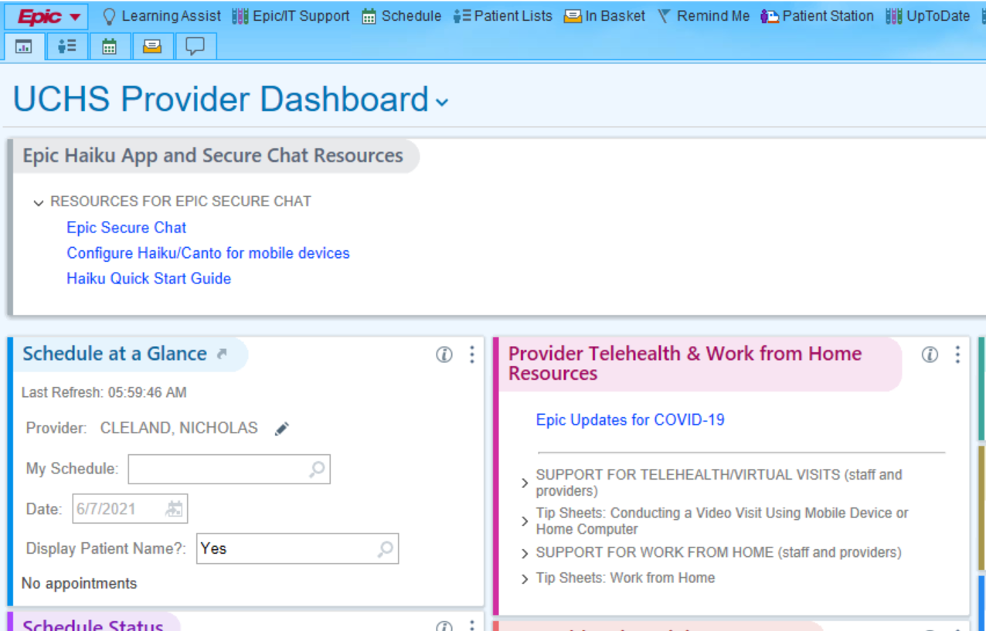
- Click the green plus sign to create a schedule. A pop up window will come up where you can create the schedule.
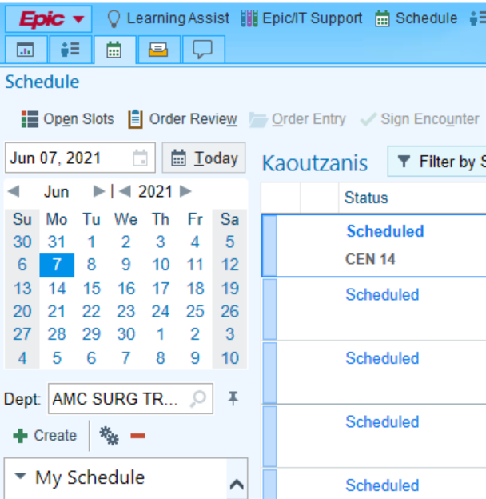
- Under the “General” tab, type in a name for the schedule you are creating. If you are doing it for all attendings, you can call it something like “Plastics”, if you are only doing it for one attending you can label it by their last name.
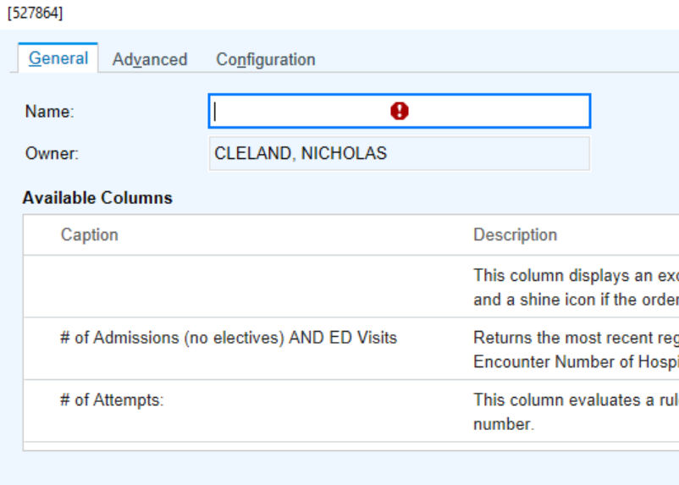
- Under the configuration tab, select “Provider [All Depts]”, and search the names of the attendings. Be sure to click on their names so they populate the “selected schedules” box. Then click accept. This will show an attending’s clinic and OR appointments.

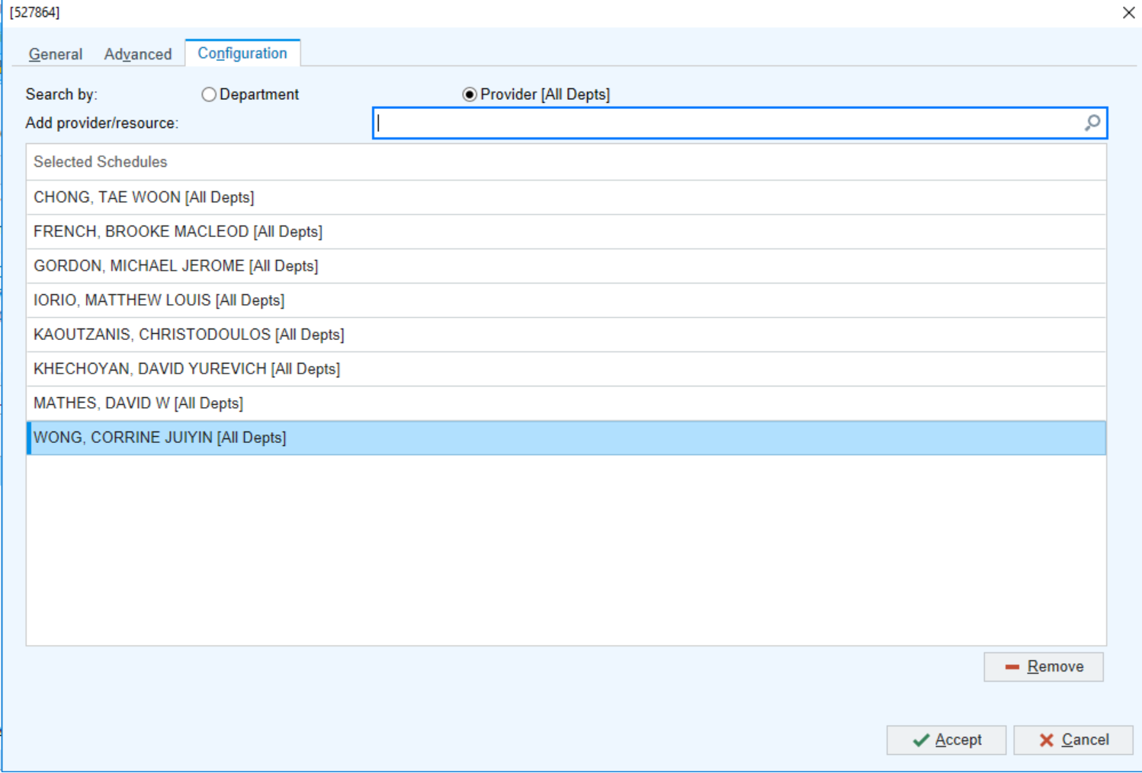
- It is recommended that you repeat this so you have one schedule for each attending and an aggregate schedule for all the attendings combined.

- To see the OR schedule, go to the top toolbar and find the “snapboard” button. You may have to click on the side arrow to see all of the toolbar options as everyone’s is different.
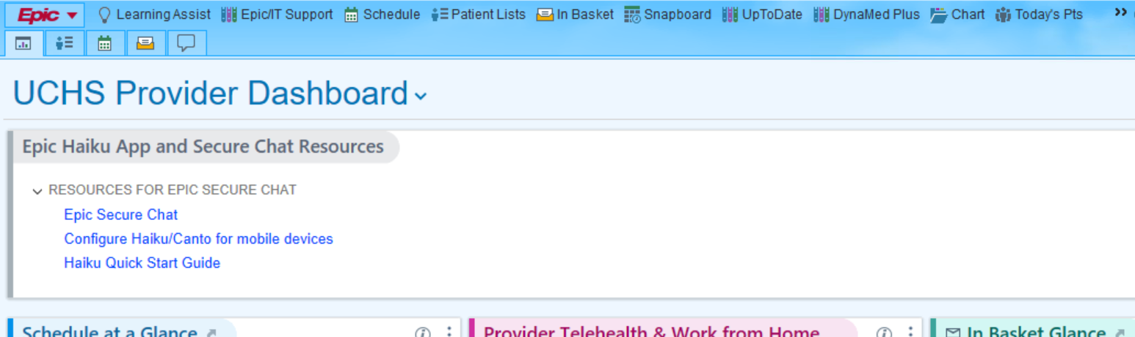

- A pop up window will open. From here you can select “AMC CEN OR Assignment Board” for the day’s Central OR schedule, “AMC EAST OR Assignment Board” for the day’s East OR schedule, as well as the next day’s schedules by selecting “AMC CEN OR T+1 Snapboard” or “AMC EAST OR T+1 Snapboard”.
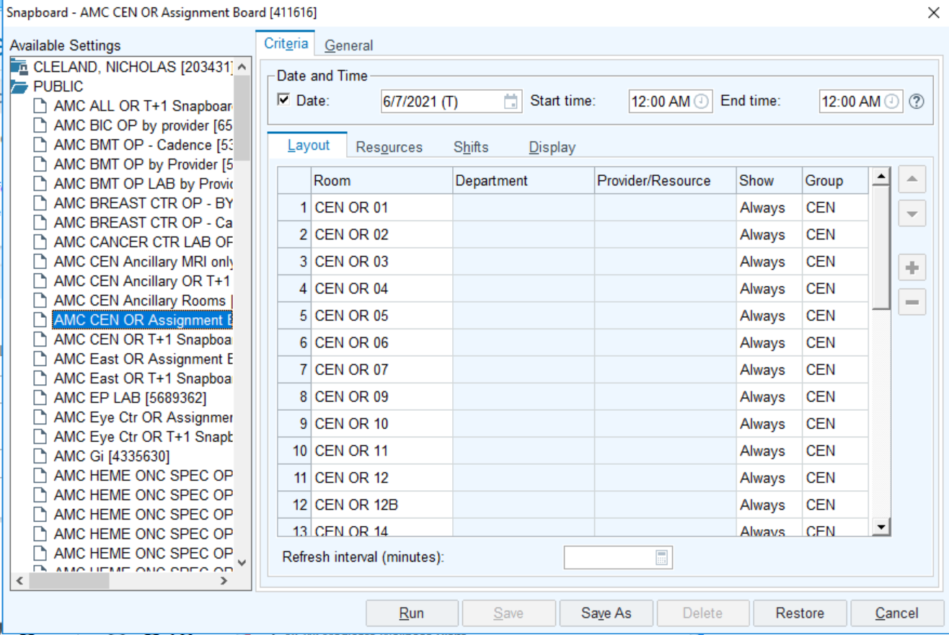
- Once in the snapboard, you can change which snapboard you are looking at by clicking on the “change snapboard report” button.
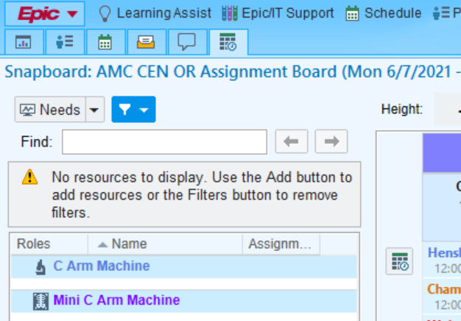
- To see schedules at Children’s Hospital, you will need to sign into your Children’s Hospital Epic. Go to https://go.childrenscolorado.org/vpn/index.html and sign in using your 6-digit user ID that can be found on your CHCO badge. Your password was set when you did the Epic training. For department you can enter “MDC Craniofacial”. Repeat the same operations as above to create the schedule for Children’s.

