How to Rock Plastic Surgery - Intern Guide

General Daily Flow
- Get sign-out from night intern on the 6th floor in middle computer flow area there is a room where they hang out; get morning list together prior to rounds
- Typically after rounds you’ll take care of floor stuff which includes vacuum changes, updating teams on any changes to the plan, writing notes, etc. If there is an R2 on service they will be the consult resident and you’ll update them on any consults, but you still may need to see them. I typically went to the OR when I was done with all of my work unless you are assigned
- If you are assigned to OR you need to be on time and they will expect you to have pre-op stuff complete for the patient
- There are Plastic PAs that are individual to the attending. They help with clinic but are also in the OR. The hand PA (Katherine) will help take hand consults if you tell her about them. As you get a consult just send a message to the hand resident with the extension that consulted you/give the consulting person the pager number of the resident on hand service.
Schedule
Monday: HAND CALL
6:30AM Plastics conference
7AM core curriculum in big auditorium where grand rounds are normally on the 1st floor
Cases
Wednesday: HAND CALL
Once per month they will have Mathes conference at 6:30
Friday: HAND CALL every other week (check schedule)
6:30 Hand conference
Cases
Weekends: HAND CALL every other weekend
Usually round/cross-cover on Saturday unless you change schedule. Let the fellow who is on that weekend know and ask when they want to round. Same deal for getting the list ready in the AM. If just rounding, once floor work is done you can sign out to the cross-cover intern. If cross-cover, good luck and you will be contacted by other services to get sign out from them throughout the morning/day.
Detailed Daily Flow
- Before rounds
- Print list: Go to plastics patient list, 1. print handoff and 2. print current list
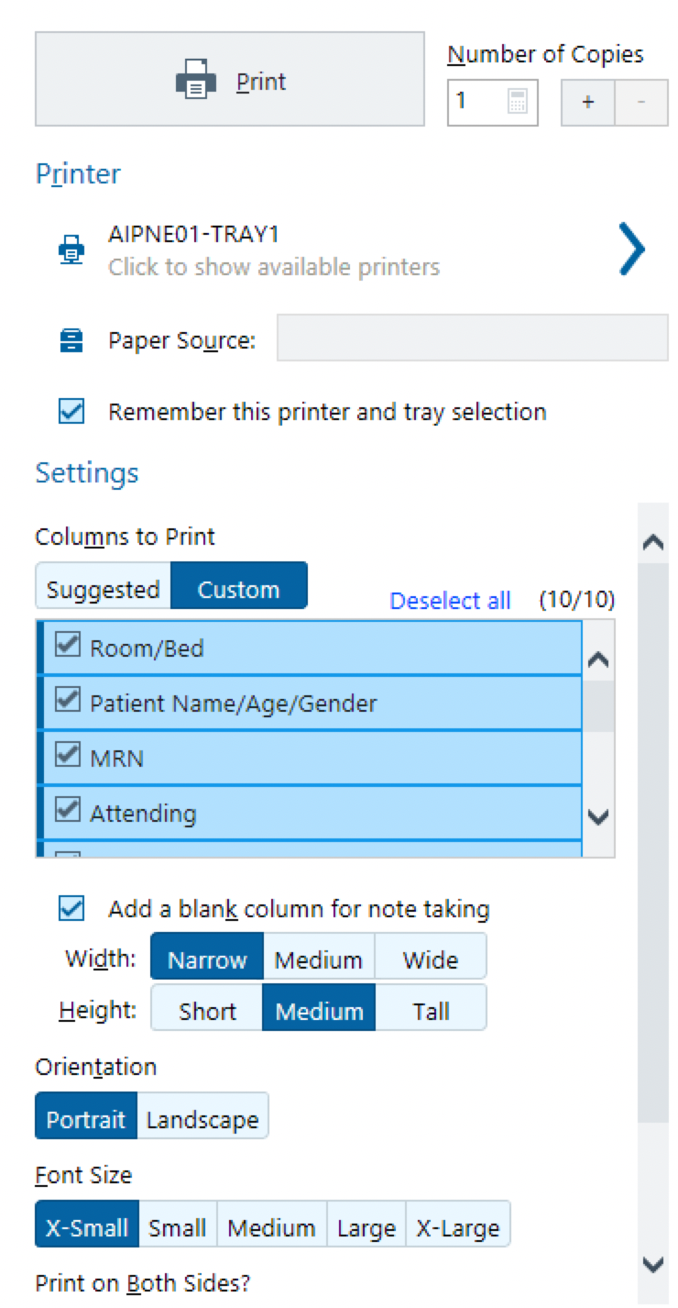
  - Current list settings (image)
- Get sign out either right when you come in, or after you get numbers. Must get this before 6 am because this is when the night person leaves
- Add the following information to the handoff
- Get vitals:
  - temp, HR, BP, RR, sats, on how much oxygen
  - I/Os: total in (24hrs),
    - In: PO/G tube in,
    - Out: UOP, NG tubes, drains, ostomy
  - Foley? Date placed
- Any recent labs
- Any new imaging
- Any culture results or pending
- Only add abnormal/pertinent vitals, drain/WV/NGT outputs, and any new culture or imaging results to list cover page
- Copy list and handoff: Copy to 2 sided and make enough copies for everyone on the team
- Rounds
- Usually either meet at fresh flap room or do gravity rounds, fellow will usually send a message out in the morning or the night before to let you know where to meet
- Before rounds start give them any patient updates that might be important to know before we start.
- At each patient room give a brief synopsis of the patient SOAP
- After seeing each patient, clarify anything you don’t understand with the resident and fellow
- At the end of rounds we run the list. This means go through every patient on the list including the ones we did not see and clarify the plan
- After rounds
- Case Management for plastics may page you to run the list and ask about patients that we are primary on as far as what are their dispo plans etc.
- Go to preop for your assigned case with the resident assigned to your case
  - update h&p, mark pt (initial and date), make sure has consent
  - If no consent available, you should consent them for their procedure
    - look at the chart the night before, understand the procedure they are getting and be prepared to consent them in the morning. If you are unsure what procedure they are getting, look at the last office visit note in which the attending/PA usually lists the OR plan. You can also look at what surgery the patient was scheduled for by checking out the surgical encounter under the encounters tab.
    - Consent:
      - Procedure: xyz + possible xyz... + other indiciated procedures
      - Benefits: improved condition of xyz or reduction of xyz
      - Risks: pain, bleeding, infection, need for future surgeries, flap failure (if it’s a flap), damage to nearby structures, scarring
      - Alternatives/Not undergoing procedure: Continued condition of xyz, worsening of condition of xyz
- If you time after preop and before case starts, the following are options:
  - Team breakfast
  - Drop orders
  - Write notes - Hint: Try and get Dr. Kaoutzanis’ notes done first.
  - Page primary teams for some patients
- Go to assigned OR
  - Leave pager with circulator in the OR so she/he can answer your pages as they come in - ask them politely to return pages as they come in, especially if it’s the consult pager.
- After OR
- After the case do post-op orders
  - Put in a brief op note - look in PACU discharge tab
  - Ask the attending what they would like as far as patient orders for home or on admission
    - Pain meds, abx, DVT ppx, dressings, special restrictions, IP consults
    - Follow-up needs
  - Place orders
  - Post op admissions:
    - Med reconciliation (where you continue orders that were previously held or home medications).
    - Don’t put the patients on antihypertensives immediately post op, check with resident when in doubt
    - DIEP orderset
    - UCH IV PCA orderset
    - UCH Gen surg post-op orderset
  - Discharge
    - PACU discharge orderset
    - Discharge instructions
      - Steal smartphrases to use in discharge instructions
      - Peggy Walsh has a lot of Chong's
      - Sara Douglass has a lot of Mathes'
      - Sometimes you can mix and match if one attending doesn't have a specific one, but make sure to change the name in the instructions
      - Follow-up:
        - In basket message to “P Plastic Surg Nurse/MA” include patient name and MRN in patient line. Write “Please schedule patient for follow-up in xyz weeks (or for a specific date if known)”
        - Pts usually follow up in 7-10 days from discharge. Clinic 720-848-0800, Nurse line 720-848-0007. Hand clinic 720-848-0485
    - Send meds to Atrium
    - Sign for narcotics in the PACU by selecting print on the order and picling up the paper script at the PACU Rx printer and put in chart or send to atrium pharmacy (tube to 514)
- Pre-op your next case, check-in with resident and fellow
- Do any unfinished floor work including finishing notes
Consults:
- If you get a consult you should let the consult resident know immediately and go and see the consult as soon as you can. The senior resident will either meet you at the consult or ask you to take pictures and send it to him
- Take pictures of consults and show the pics to the fellow even if they are scrubbed in
Cases can be in either AOP or AIP, so look to see where the pt is and go preop them
Discharges:
For complicated patients, call to schedule an appointment (Nicole for plastics 82211, or Kaylie for hand 83372). Otherwise, make sure to put the phone numbers in their discharge instructions and type out that they need to call to schedule a follow up for in 7-10 days.
You can “T-up” discharges (Get them ready because you know they will be leaving soon)
- Use discharge tab, and go through reconciliation. Restart home meds as appropriate, and d/c inpatient meds.
- Prescribe any pain meds or abx that may be needed (Make sure you go to the Rx printer closest to the patient to sign narcotic scripts then either put in chart or send to atrium pharmacy (tube station 514)
- Surgeries involving muscles (eg flaps, tissue expanders) should go home with oxy and valium; TEs also go with antibiotics and surgical bra (Nurse may have to call central supply to get a second bra for the patient if this is needed)
- Flaps should go with a 30 day script for baby aspirin, 2 weeks lovenox, oxy, valium, abdominal binder
- Click on the discharge order set and fill in, return precautions, clinic number, follow-up information (use dot phrases for some of this)
- It will automatically pull up a "discharge pt" order that you can remove under summary
- Sign these orders, make sure narcotics and/or all the scripts are "print" when you put them in. You can change this within the order. Some pts like to take their scripts to other pharmacies and you can only send them to the Atrium pharmacy. Have fellow sign scripts in the morning. When clicking "sign" it will prompt you with a screen that shows the attending's name under medication prescription, you can change this to the fellow's name, and that way they can sign it with their DEA number. **Scripts print to where the pt is (eg if on the 7th floor, will print to main 7th floor nursing station script printer, if they are in PACU it will go to PACU)
- On actual day of discharge, you will only need to put in a "discharge pt" order and a "discontinue IV" order
Can start discharge summary at any point, and share it. Make sure to have one signed within 24 hours of discharge.

End of day:
Update the handoff based on new information or changes throughout the day. Include plans for the following day/week if applicable ie. change wound vac tomorrow
Find your fellow (they may be in the OR) and either run the list (can do this while they are scrubbed in)/round on patients, ask what else is going on, update them on what you have done and what is going on on the floor
Sign out is at 6 PM, there may be a line so it may take some time; try to be the first one there to sign out, otherwise you will have to wait until other teams (with longer list) are done signing out
Tell night person a brief one liner and what you guys are doing for them. Assume they do not know the person because they carry 6-9 pagers on any given night.
Make sure to let them know if they need to do a postop check (eg pt just got out of the OR/still in the OR/in PACU)
Make sure to let them know if there is anything to follow up and if they should talk to someone about results: eg labs, urine output, a void if a foley was pulled...
Let them know which resident and fellow is on call for that night. Put their names, pager and cell phone numbers at the top of the list.
Miscellaneous things:
Chong and Mathes flaps get advanced to NO caffeine diets.
All flaps should be on a baby aspirin.
Gordon has his own hand discharge instructions under the discharge tab. If you search for instructions (not smartphrases), just look for Gordon and his postop instructions will come up.
Steal all the smartphrases! They are your best friend
ALWAYS put in specific wound care orders if needed, either in a nursing communication or in a wound care order. Be very specific, otherwise you will get paged a bunch and it won't be done right. Specific to the point where you tell them "use a 4 inch ACE wrap", etc.
If you are confused, or not certain about a pt and their discharge, ask your resident, fellow or the APPs on the service. They are the ones mostly see the pts in follow ups at clinic, so they can tell you what they are looking for or what the pt needs to be sent home with specifically.
White surgery/Breast is primary on mastectomy/tissue expander combo cases
On the list, write who is the primary team
Numbers – (or 84845# universal code)
Sixth floor nutrition room: 6060#
Ninth floor supply room: 9191#
Tenth floor supply room: 0180
Teaching Topics for Students -- Flap checks, wound vac principles and how to change them, deep dermal and running subQ sutures (these are what you will do mostly in the OR).
Hand Call
History: For all pt's list their name, handedness and what they do (i.e. is fine dexterity extremely important to them, concert pianist vs receptionist). Note if the fracture is open or closed and make sure to do a neurovascular exam.
Distal radius fractures: Inject 10cc lidocaine into the fracture (area of swelling and pain) site and hang pt's arm with finger traps. This will reduce the tension on the muscles and allow the fracture to be reset.
Hand Worksheet: 