We usually have an intern, but they've been trying to skimp on us lately. If this becomes an issue, let Dr. Mathes know, because the service really is starting to get busier. We also have a PA, Krysta Bearish, who is awesome, but she is also part of the Breast service. She can see ED consults and patients, and helps out in the OR. We don’t have a scheduler right now, so she’s wearing both hats. She works Tuesday - Friday.
Clinic - Tuesday AM 8-11:30. We are in Maroon Peak clinic. 3rd floor specialties clinic in Building E, in rooms 224 - 228. 3-2-4 “enter” is the code to the door to get back into the clinic from the waiting room. They're using this VetLink program now to show when patients arrive. Once the vital signs are taken, you call for the patient yourself and bring them to your room. You can edit the memo to say you are seeing the patient by adding your name/initials or adding “done” in the memo if the patient has been seen so everyone else is on the same page. The attendings have been using the 3rd room (room 228) from the main door as his office. Since we only have 3 assigned rooms, Krysta will often use one of the Thoracic rooms if an intern is helping in the clinic. Krysta will typically see the pre-ops, and the fellow/resident will see the new patients, and the intern will see everyone else. Obviously, if things fall behind, you see anyone. I also encourage you to at least peek in on your post-ops, as you are afforded quite a bit of independence in the OR and it’s a good way to learn from your mistakes. **Because of COVID, we are disinfecting the rooms ourselves between patients).
If you have a case to schedule, the patient should be provided a business card with the contact information for the office (Krysta has those available). Sometimes we can offer them an OR date same day, but most of the time she will call them later in the week to get them onto the schedule.
For pre-ops, patients need: an H&P, pre-op labs (under pre-procedure labs), signed consents (consents are electronic: under “Tools” 🡪 iMed Consents 🡪 Plastic Reconstructive Surgery 🡪 Consents Basics 🡪 then select appropriate consent and follow prompts).
Surgery - Thursdays. Usually in OR 1. 3rd floor of building D. You have a locker, I don’t know what the male locker is, but the women’s is #90. Please be aware that they have a tendency to take our lockers away, so let Krysta know if this happens. She can talk to Dr. Robinson about it. The code to get into the locker rooms and the break room is 145 enter. Our scrub card doesn't work anymore. I just used old scrubs that I had on hand (the children’s blue scrubs), but I think you can talk to some guy named Hugo (?) in the basement to have your card activated.
If you want to put in pre-surg orders so you don't get paged at 5:30 am on Thursdays, you put them in under the RMR OR Plastics MD visit encounter. Have one of the interns show you how to do it. (Note: Krysta has been taking care of this for us as she mostly sees the preops in clinic)
Notes - in clinic, make sure you always set up an encounter, a primary provider, and a diagnosis (The first 2 tabs when you set up the encounter). Then write the note - there are specific plastic surgery headings to select. You can create your own template or use a pre-populated one. Before I made my own templates, I often used the Urology clinic note template). When you sign the notes - add the attending and Krysta as co-signers. Also order clinic follow up appoints (RTC - specialty clinic - plastics).
If you are seeing a NEW patient consult: “Plastic Resident/Fellow Consult Note”
If you are seeing a patient for follow-up, post-op: “Plastic Resident/Fellow Clinic Note”
If you are seeing a pre-op: “Surgical pre-op H&P” then follow the prompts and check all the boxes*

Dictations: The attendings expect us to dictate all of the operative reports. Attached below are the dictation instructions. Your dictation code is 45 followed by your pharmacy ID.
If you admit patients, they usually go to the 3rd floor of building K.
SCI - this place is going to make our service busier each month. It is located one the first floor of building H. This unit is run by PMNR doctors and wound care. Once a month, there is a meeting before clinic (7:15 am), where we go over patients at a multidisciplinary meeting. I’ve found that they typically call Krysta with patients who need decubitus ulcer coverage. Our criteria is that their co-morbidities are relatively well-controlled, osteo has been addressed, and their albumin is 3 or above. The unit can be very eager about getting these patients to the OR, so be on your toes to ensure nothing is missed in optimizing the patients. Intraoperatively, Dr. Mathes typically does V-Y advancements, and Dr. Gordon does rotational flaps. Postoperatively, Dr. Mathes typically likes to keep the patients on antibiotics until the bone biopsies result. The SCI has a whole protocol for postoperative management. Typically sutures stay in 4-5 weeks (sometimes longer for Dr. Gordon’s patients), the drains stay in until dust comes out of them (typically 4-5 weeks). Gordon likes to keep his dressings on until they get soiled underneath. I’ve left them on for about 4 weeks once. Mathes has his dressings removed in 24-48 hours. After the 6th week, the SCI starts with their stretching protocol, and this is typically the time I stop seeing the patients. The wound care team here is amazing, always helping to turn and prep the patients, and manages dressings per our instructions. We will typically round on any current inpatient SCI patients on Tuesday afternoon, after clinic. The intern can round with the team, and Krysta is also willing to help with this for continuity.
Important numbers:
Krysta: 720-737-4532 (office 720-857-5817)
VA Prefixes: 720-857-xxxx or 720-723-xxxx.
Vocera: 720-723-7997 or 1-7997 (in-house), then say the name of the person you want to call (example: Pre-op charge nurse, K3 [room number] nurse, OR 1 nurse, radiology, outpatient pharmacy, etc.)
Jenn Hutton, wound care nurse in the SCI: 720-469-8217
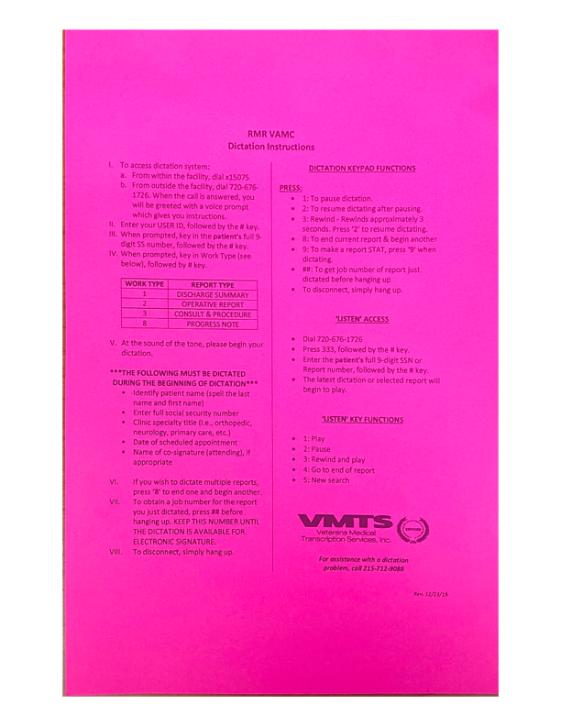

You can use these templates if you’d like. Follow the instructions below:

You will need to be under Notes, then go to “Options” 🡪 “Create New Template” and then Name: the template whatever you would like. Make sure to click “Apply” to save changes and then “OK.”

NEW PATIENT

CC:

HPI: |PATIENT AGE| y/o |PATIENT SEX| who presents today for evaluation of

PMH:

|PROBLEM LIST ACTIVE (SHORT)|

PSH:

FHx:
- Family history of cancer:
- No family history of bleeding disorders, clotting disorders, or difficulty tolerating anesthesia.

SHx:
SHx:
Occupation:
Lives with:
Tobacco:
ETOH:
Marijuana:
Other Drugs:

===============================================================================

ALLERGIES: |ALLERGIES/ADR|

MEDICATIONS:

Active Outpatient Medications:
|ACTIVE/PENDING/EXPIRED MEDICATIONS (W/O SUPPLIES)|

I have reviewed the patient's medication list with:
{FLD:PATIENT/CAREGIVER} and I have indicated discrepancies
under each medication that is not being prescribed. Medication
orders, including any additions or discontinuations, have been
updated as appropriate, and the patient/caregiver now have an
accurate medication list.

Medication education and counseling for new medications added today
was provided to the Patient/Caregiver. This included why the
medication was prescribed, how they should take it and for how long,
what to expect from it, and what happens if medication is not taken
as prescribed. Patient/Caregiver indicates readiness to learn,
verbalizes understanding and agreement. A copy of the updated
medication list was also given that included the new medication(s).

ROS:

General: No recent illness, fevers, chills, fatigue; +wt stable
Skin: No rashes or itching. No open wounds or abrasions.
HEENT: No neck swelling/pain. No lymphadenopathy.
Cardiac: No chest pain, palpitations, murmurs, MI or HTN.
Resp: No dyspnea/shortness of breath. No hx COPD or asthma.
GI: No abdominal pain, nausea, vomiting, constipation, or diarrhea.
GU: No urinary frequency. No hx of renal failure or dialysis.
ENDO: No hx of thyroid disease. No hx of diabetes mellitus.
MSK: No muscle pain, weakness, or swelling.
Vasc: No history of DVT or PE. No hx easy bleeding/bruising.
Neuro: No weakness, numbness, tingling.
Psych: No recent changes in mood.

===============================================================================

PHYSICAL EXAM:

Vitals:
TEMP: |TEMPERATURE|
BP: |BLOOD PRESSURE|
RR: |RESPIRATION|
HR: |PULSE|
HT: |PATIENT HEIGHT|
WT: |PATIENT WEIGHT|
Pain: |PAIN|
SPO2: |PULSE OXIMETRY|
BMI: |BMI|

General: Alert and oriented x 4, WNWD, NAD
Skin: No rashes, erythema, or notable scars.
HEENT: NCAT, PERRLA, face symmetric.
Cardiac: RRR; no murmurs, rubs, or gallops.
Resp: CTAB; no wheezes, rhonchi, or rales. Chest symmetric.
GI: No asymmetry or scars noted. +BS in all 4 quadrants.
Non-tender to palpation. No guarding or rigidity. No palpable masses.
No hepatosplenomegaly.
MSK: FROM of UE/LE B/L
Vasc: Distal pulse palpable and symmetric. No edema or pitting edema noted.
Lymph: No palpable lymphadenopathy.
Neuro: CN II – XII grossly intact. Gait steady.

===============================================================================

LABS:

IMAGING:

===============================================================================

A/P: |PATIENT AGE| y/o |PATIENT SEX| who presents today for evaluation of

The patient was seen today by Dr. (*) and myself. We have reviewed the following in detail with the patient today:

Patient states they understand these recommendations and are in agreement with this plan. They asked many good questions today and all of their
questions were answered. The patient was provided direct office contact information and encouraged to contact our office directly with any
additional questions or concerns.

Patient discussed with attending Dr. (*) today in clinic, who agrees with the medical management outlined in my note and believes it is medically
necessary.

FOLLOW UP

CC: follow up visit

HPI: |PATIENT AGE| y/o |PATIENT SEX| who presents today s/p

Patient was last seen in clinic on *

No changes in PMH, SHx, SocHx, or FHx since last visit.

ALLERGIES: |ALLERGIES/ADR|

MEDICATIONS:
I have reviewed the patient's medication list with the patient and there are no changes to current medications since last visit.

ROS: per HPI, otherwise negative

===============================================================================

PHYSICAL EXAM:

Vitals:
TEMP: |TEMPERATURE|
BP: |BLOOD PRESSURE|
RR: |RESPIRATION|
HR: |PULSE|
HT: |PATIENT HEIGHT|
WT: |PATIENT WEIGHT|
Pain: |PAIN|
SPO2: |PULSE OXIMETRY|
BMI: |BMI|

General: Alert and oriented x 4, WNWD, NAD
Skin: No rashes, erythema.
HEENT: NCAT, PERRLA, bilateral EOMI.
Cardiac: RRR, no cyanosis
Resp: non-labored breathing on room air
MSK: FROM of UE/LE B/L
Neuro: Gait steady.
Incision: Well healed. No erythema, swelling, draining, or dehiscence noted.

PATHOLOGY:
|HSO SURG PATH 5WK|

===============================================================================

A/P: |PATIENT AGE| y/o |PATIENT SEX| who presents today s/p

The patient was seen today by Dr. (*) and myself. We have reviewed the following in detail with the patient today:

1) Patient is overall healing well since surgery.
2) Will plan to see patient for a follow up visit (*)
3) Post-op wound care instructions were discussed:
- Keep incisions clean and dry. Pt may shower.
- Monitor for any signs or symptoms of infection we have discussed.
- Activity restrictions:
= May resume normal activities as tolerated.
= May use scar massage daily with silicone/water base moisturizer.

Patient states they understand these recommendations and are in agreement with this plan. They asked many good questions today and all of their
questions were answered. They were provided direct office contact information and encouraged to contact the office with any questions or concerns.

Patient discussed with attending Dr. (*) today in clinic, who agrees with the medical management outlined in my note and believes it is medically
necessary.

POST-OP

CC: post-op visit

HPI: |PATIENT AGE| y/o |PATIENT SEX| who presents today s/p

Incisions are healing well. Pain is well controlled without narcotics/pain medication. No abd pain, fevers, chills, nausea, or vomiting. Appetite
is intact. BMs regular.

No changes in PMH, SHx, SocHx, or FHx since last visit.

ALLERGIES: |ALLERGIES/ADR|

MEDICATIONS:
I have reviewed the patient's medication list with the patient and there are no changes to current medications since last visit.

ROS: per HPI, otherwise negative

===============================================================================

PHYSICAL EXAM:

Vitals:
TEMP: |TEMPERATURE|
BP: |BLOOD PRESSURE|
RR: |RESPIRATION|
HR: |PULSE|
HT: |PATIENT HEIGHT|
WT: |PATIENT WEIGHT|
Pain: |PAIN|
SPO2: |PULSE OXIMETRY|
BMI: |BMI|

General: Alert and oriented x 4, WNWD, NAD
Skin: No rashes, erythema.
HEENT: NCAT, PERRLA, bilateral EOMI.
Cardiac: RRR, no cyanosis
Resp: non-labored breathing on room air
MSK: FROM of UE/LE B/L
Neuro: Gait steady.
Incision: Healing well. No erythema, swelling, draining, or dehiscence noted.

PATHOLOGY:
|HSO SURG PATH 5WK|

===============================================================================

A/P: |PATIENT AGE| y/o |PATIENT SEX| who presents today s/p

The patient was seen today by Dr. (*) and myself. We have reviewed the following in detail with the patient today:

1) Pathology was reviewed in detail.
2) Will plan to see patient for a follow up visit (*)
3) Post-op wound care instructions were discussed:
- Keep incisions clean and dry. Pt may shower.
- Monitor for any signs or symptoms of infection we have discussed.
- Activity restrictions:
= No heavy lifting, straining, or aerobic exercises.
= No swimming, hot tubs, or baths until wound fully healed.

Patient states they understand these recommendations and are in agreement with this plan. They asked many good questions today and all of their
questions were answered. They were provided direct office contact information and encouraged to contact the office with any questions or concerns.

Patient discussed with attending Dr. (*) today in clinic, who agrees with the medical management outlined in my note and believes it is medically
necessary.

