Dragon Voice Recognition: PowerMic Mobile
- PowerMic Mobile is an additional license and is not offered to all providers. An email with step-by-step instructions on how to configure your phone will be sent out after a license has been granted.
- Using PowerMic Mobile will drain your Smart Phone battery.
- Anytime your phone times out and the screen goes black, or when receiving a call, a Pairing PowerMic Mobile screen will appear until you turn your screen back on. It should reconnect automatically.
- To turn on the microphone, click the microphone icon on the Smart Phone, no need to press and hold.
Change back and forth between your Smart Phone and a PowerMic II

- Click on Blue Nuance flame
- Click Log off (brings up Log on screen)
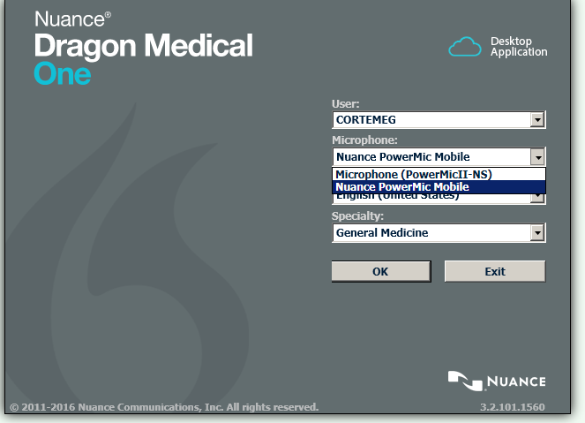
- Change your microphone option
- Click OK
Pairing PowerMic Mobile
- Launch PowerMic Mobile on your Smart Phone
- Open Dragon through Epic and have PowerMic Mobile selected as your microphone
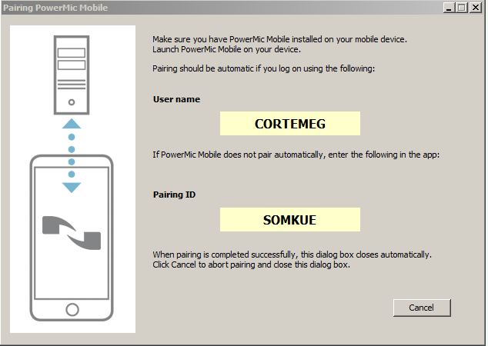
- PowerMic Mobile should paired automatically. If not, you will get the following screen:
- On your Smart Phone, click Enter Code
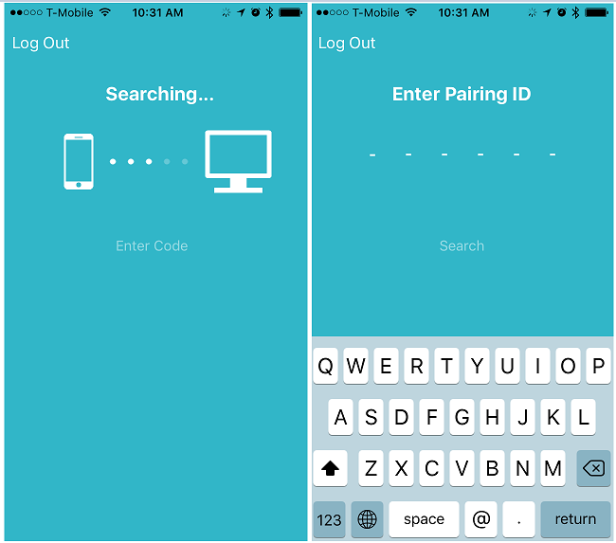
- Enter the 6 digit Pairing ID into the Smart Phone app.
Setting up Microphone Buttons
- Click on Blue Nuance Flame
- Click Options
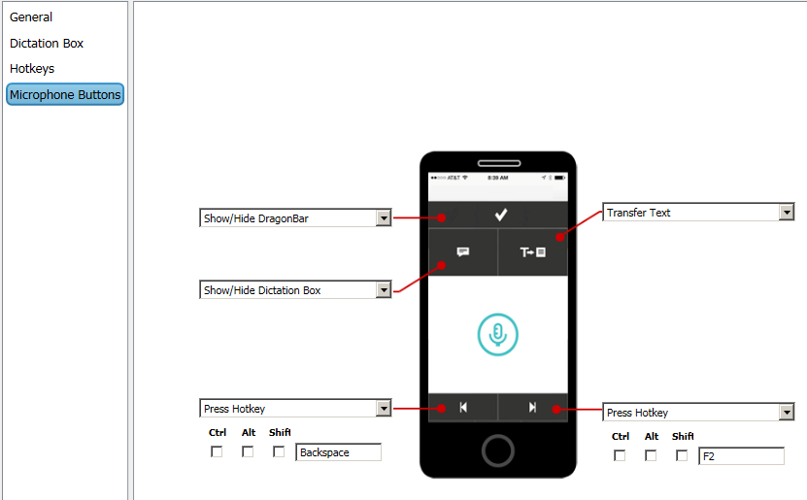
- Click Microphone Buttons
- Click on the dropdown menu and select Press Hotkey
- Place cursor in the blank box and press F2 key (or another key of your liking) on the keyboard.
- Click Apply All and then, Close.

